The Formation of the Universe
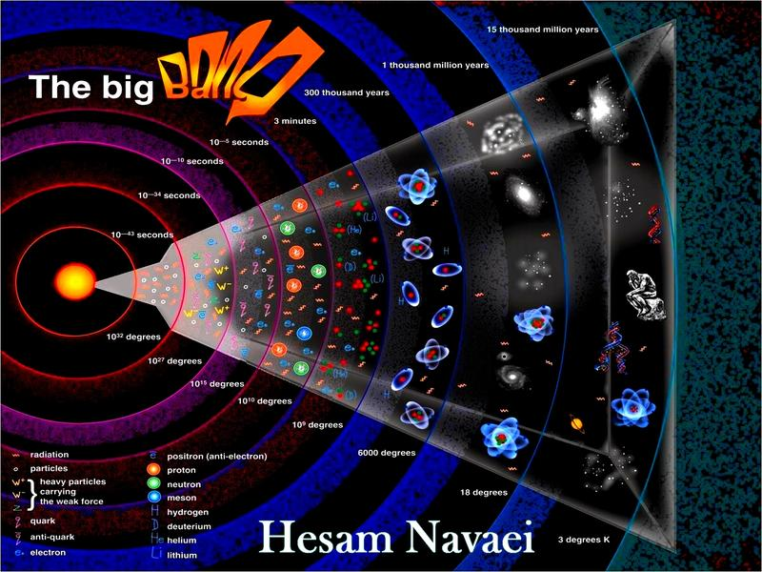
Use the picture below to answer questions 1 to 6.
This is a time line representing the formation of everything in the universe
- How old is the universe?

- After the Big Bang, how long did it take for the nucleus of atoms such as Hydrogen and Helium to form?

- How old was the universe when the fist atoms were formed?

- How hot was the universe when it was formed?

- Which element was born after 1 thousand million years after the Big Bang?

- How old was the universe when men were formed?
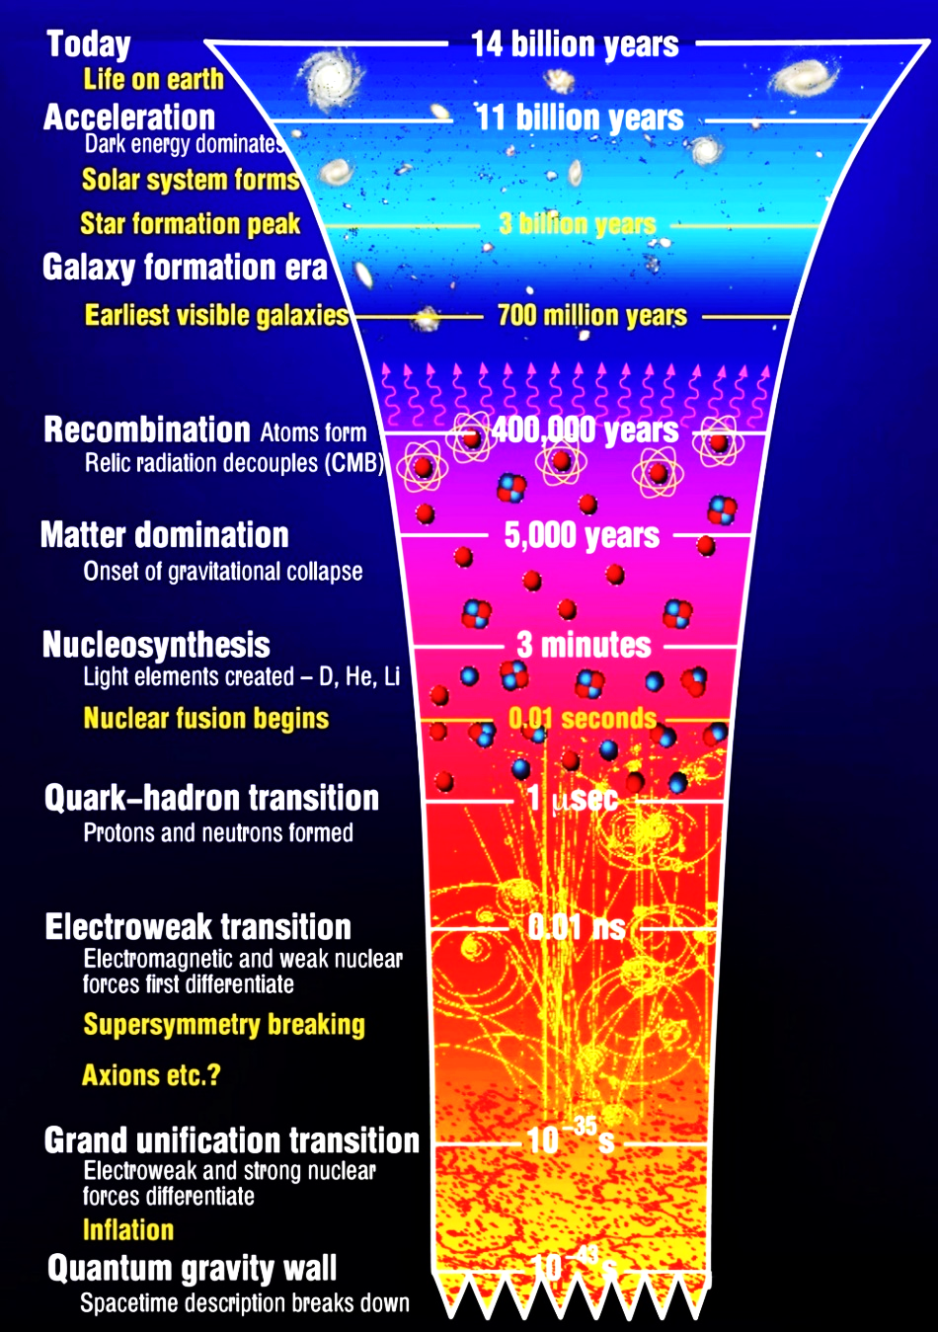
Use the picture on the right to answer questions 8 to 11
- How much time did it take, after the Big Bang, for protons and neutrons to form?

- When was nuclear fusion of simple elements formed?

- When were the first galaxies formed?

- When was our solar system form?

- At what age did the universe accelerated faster

Use the Balloon picture to answer questions 12 to 17
- What does the balloon represents?

- What is happening to the balloon with time?

- The white marks in the balloon, what do they represent?

- What is happening to the distance between the white dots as time increases

- Are the Galaxies (dots) growing with time?

- In which direction are the dots moving as the balloon grows?
