Blue Shift
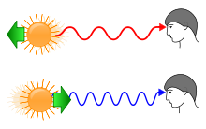
The stretching of light waves seen as shifted towards the blue part of the spectrum; happens when object and observer are moving toward each other.

Red Shift
The stretching of light waves that can be seen as shifted towards the red part of the spectrum; happens when object and observer are moving away from each other.
Infrared Radiation

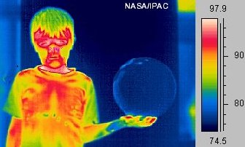

Waves of the electromagnetic spectrum that can be felt as heat.
Microwaves

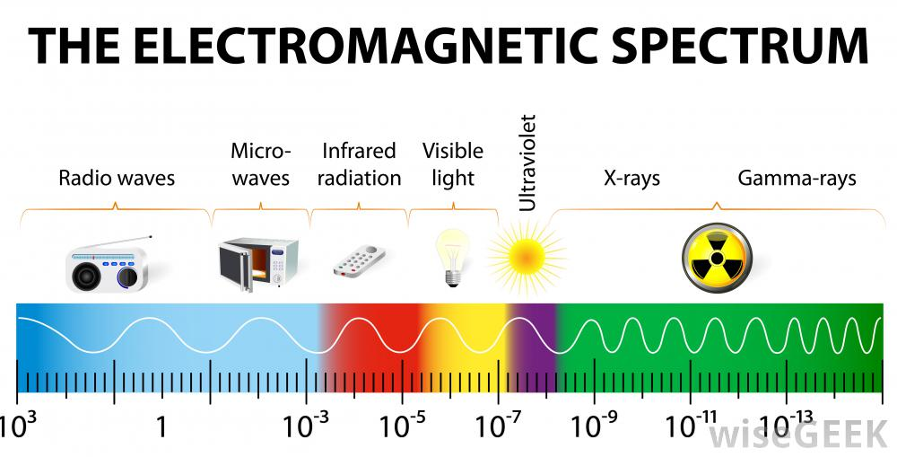
Long waves of the electromagnetic spectrum that are used to heat food, to produce radar images and to produce weather reports.
Frequency
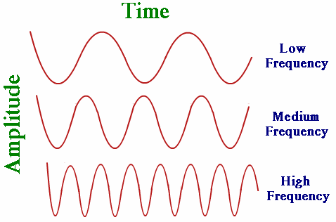
The number of electromagnetic waves traveling and passing through a certain area in one second.
Gamma Rays
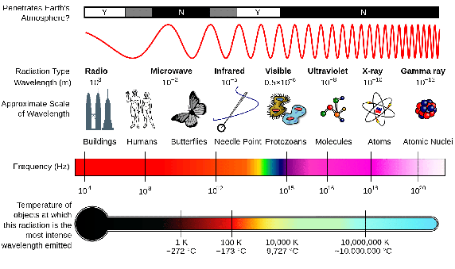
Shortest waves with the most energy and highest frequency on the electromagnetic spectrum. They are used in medicine to kill bad living cells.
Radio Waves
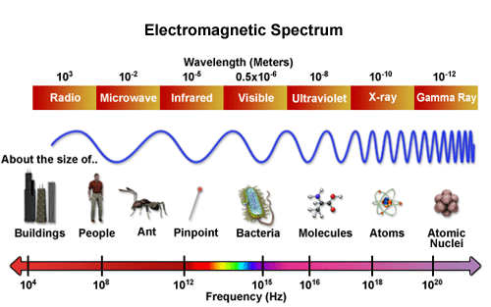
The longest waves of the electromagnetic spectrum that are used to communicate and transmit information through long distances. The waves are as long as a football field.
Visible Light
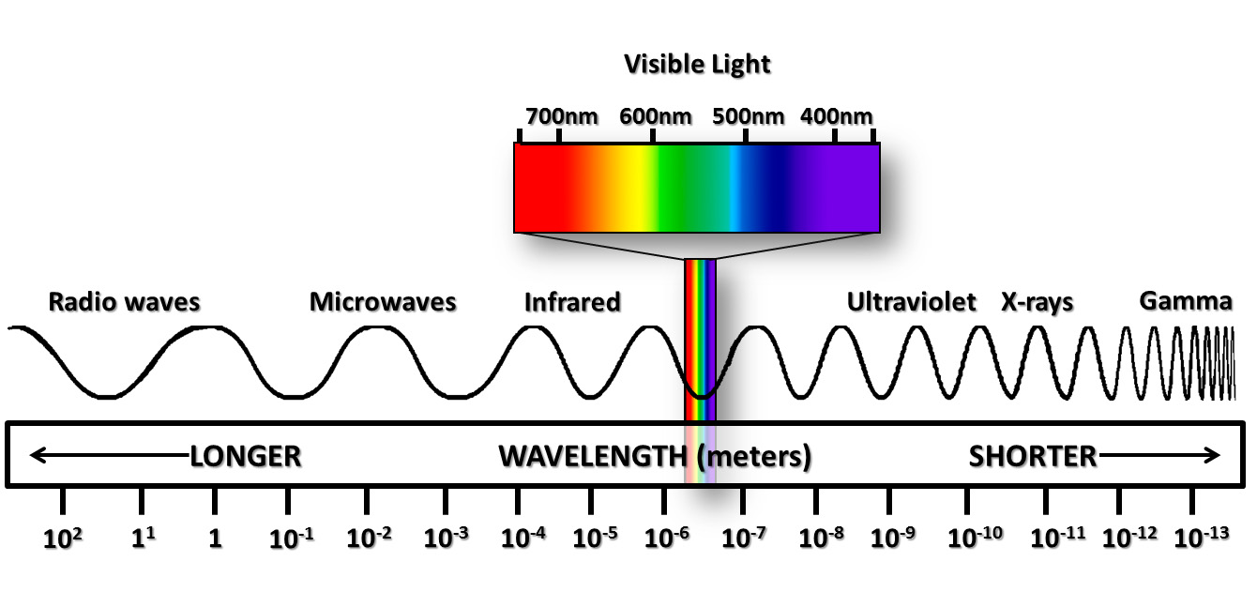
The only electromagnetic waves emitted from stars and galaxies that are visible. They are made of all the colors of the spectra.
Ultraviolet Radiation
Waves in the electromagnetic spectrum that can penetrate the atmosphere and burn your skin.
X-rays
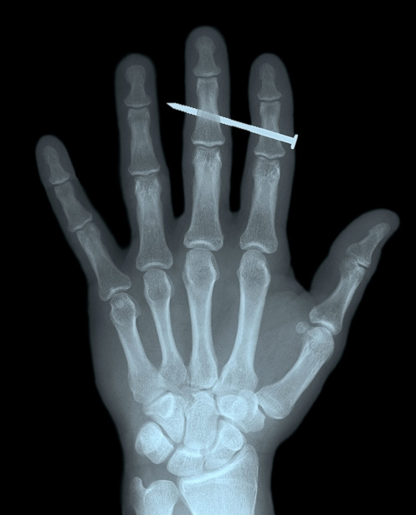
Short waves of the electromagnetic spectrum that can penetrate your body’s soft tissue. They are used to create images of bones for medical purposed.

