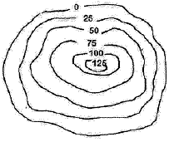
Foam Topographic Maps

Purpose: Creating a 3-D topography geological feature.

Procedure:
- Use different sizes of foam to create a small geological formation.
- Trace each geological piece to create a topographical map of the geological structure.
- Indicate the index contour lines and number the contour lines in increments of 50 m.
- Create a profile of the geological and match up the lines to the topography lines.
- Glue your topography map, rules, and geological feature to a construction paper.
- Must have 5 to 7 levels. Should have a steep side and a gradual slope.

Topographical Geological Map
Topography Profile Map

___________________________________ ____________________________________
___________________________________ ____________________________________
___________________________________ ____________________________________
___________________________________ ____________________________________
___________________________________ ____________________________________
___________________________________ ____________________________________
___________________________________ ____________________________________
___________________________________ ____________________________________
___________________________________ 0 ____________________________________

