Name ______________________________________ Date ____________________ Period _______
Life Cycle of a Star
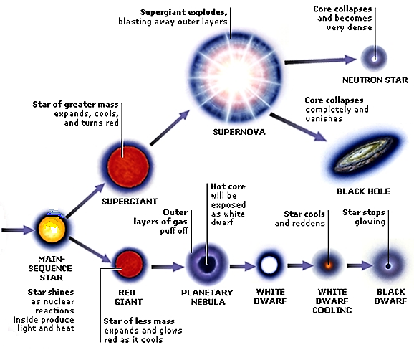

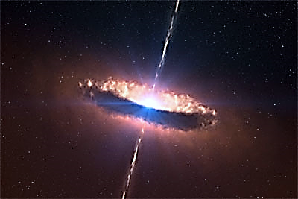

A protostar is a star in its early stages that is gathering hydrogen gas and dust before nuclear fusion begins

A STAR IS BORN – All stars start as a nebula. A nebula is a large cloud of hydrogen gas and dust. Gravity can pull some of the gases and dust together. The contracting cloud is then called a protostar. A protostar is the earliest stage of a star’s life. A star is born when the gas and dust from a nebula become so hot that nuclear fusion starts. Once a star has “turned on” it is known as a main sequence star. When a main sequence star begins to run out of hydrogen fuel, the star becomes a red giant or a red super giant.
THE DEATH OF A LOW OR MEDIUM MASS STAR. After a low or medium mass or star has become a red giant the outer parts grow bigger and drift into space, forming a cloud of gas called a planetary nebula. The blue-white hot core of the star that is left behind cools and becomes a white dwarf. The white dwarf eventually runs out of fuel and dies as a black dwarf.
THE DEATH OF A HIGH MASS STAR. A dying red super giant star can suddenly explode. The explosion is called a supernova. After the star explodes, some of the materials from the star are left behind. This material may form a neutron star. Neutron stars are the remains of high-mass stars. The most massive stars become black holes when they die. After a large mass star explodes, a large amount of mass may remain. The gravity of the mass is so strong that gas is pulled inward, pulling more gas into a smaller and smaller space. Eventually, the gravity becomes so strong that nothing can escape, not even light.
Section One- Sequencing: The stages below are not in the right order. Number the stages in the correct order.
______The star begins to run out of fuel and expands into a red giant or red super giant.
______Stars start out as diffused clouds of gas and dust drifting through space. A single one of these clouds is called a nebula.
______What happens next depends on the mass of the star.
______Heat and pressure build in the core of the protostar until nuclear fusion takes place.
______The force of gravity pulls a nebula together forming clumps called protostars.
______Hydrogen atoms are fused together generating an enormous amount of energy igniting the star causing it to shine.

Section Two – Vocabulary: Match the word on the left with the definition on the right.
____ black dwarf e. star left at the core of a planetary nebula
____ white dwarf g. a red super giant star explodes
____ nebula c. what a medium-mass star becomes at the end of its life
____ protostar b. a large cloud of gas or dust in space
____ supernova a. exerts such a strong gravitational pull that no light escapes
____ neutron star d. the earliest stage of a star ’s life. No nuclear fusion exists yet
____ black hole f. the remains of a high mass star

Section Three – Understanding Main Ideas - Low Mass Star (use the picture above)
____ 1. Red giant
____ 2. Protostar
____ 3. Stellar Nebula
____ 4. Black Dwarf
____ 5. The stage where our sun is fusing hydrogen into helium
____ 6. White dwarf
____ 7. Planetary Nebula

Section Four – Understanding Main Ideas - High Mass Star (use the picture above)
______ 1. Black Hole
______ 2. Supernova
______ 3. Stellar nebula
______ 4. Gravity causes hydrogen gases and dust to condense into a protostar
______ 5. Main sequence star
______ 6. When a star begins to run out of fuel and grows larger
______ 7. Neutron star

Section Five- Graphic Organizer. Fill in the blanks

Section six – Venn Diagram- Compare and Contrast

