6.5C

- Create a T-chart to compare and contrast elements and compounds.

Elements | Compounds

6.5C

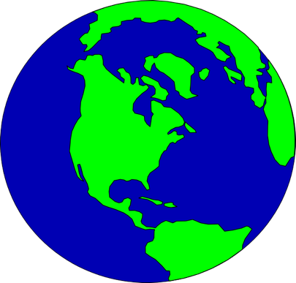
- Think about where you might find elements and compounds in the world. Write at least 3 sentences explaining the difference between compounds and elements.

6.5C

- Put the following terms in order from smallest to largest.

Compound, Element, Human, Atom, Matter

6.5C

- Which of the following is a compound made of exactly 2 elements?

  - O₂
  - H₂O
  - 2N₂
  - C₆H₁₂O₆

