6.6A

- Complete the key to label each section as metals, non-metals, or metalloids.
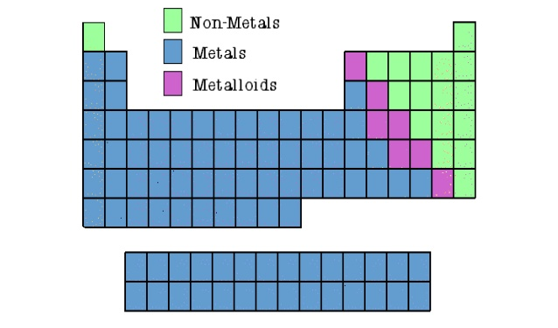

6.6A

- Look at the following picture. Think about the physical properties used to identify metals, non-metals, or metalloids. Write a paragraph explaining how you would classify this image below.
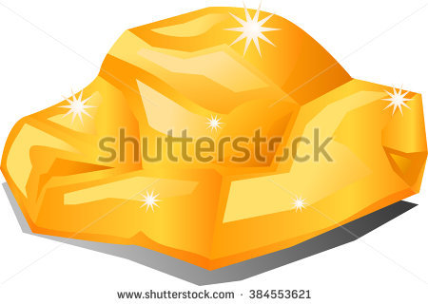
6.6A

- Use the graphic organizer below to sort the following characteristics:
Malleable, Brittle, Dull, Shiny Luster, Conductor, Insulator
Metals | Non-Metals
6.6A

- Which element is classified as a metalloid?

Element | Luster | Conductivity | Malleability
Titanium | Shiny, White | Conducts heat and electricity | Can be rolled into thin sheets easily
Selenium | Dull | Poor conductor of heat or electricity | Brittle, breaks easily
Potassium | Silvery, Shiny | Conducts heat and electricity | Can be shaped into think sheets
Polonium | Metallic | Semi-conductor of electricity and heat | Can somewhat be shaped into sheets

