6.6B

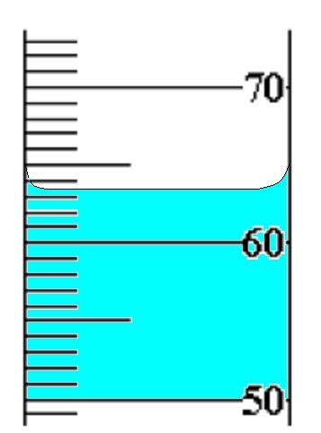
- A ring is placed in a graduated cylinder that had 59 mL of water in it. The water rose as
shown in the picture below.
What is the density of the ring if
its mass is 70 grams?
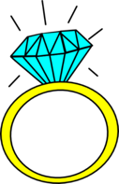

6.6B

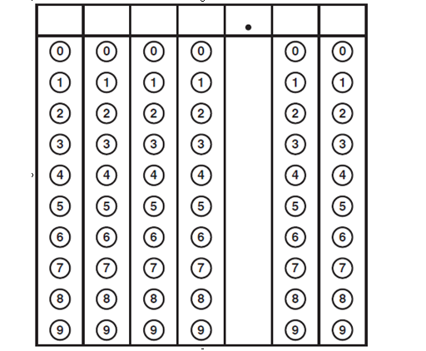
- An object has a mass of 20 grams and a volume of 2.5 mL. What is its density? Use the griddable to record your answer.

6.6B

- If an object has a mass of 77.2 grams and a volume of 4 mL, what could the object be made of? Use the table below.

Substance | Density g/mL
Wood (Oak) | .85
Aluminum | 2.7
Lead | 11.3
Gold | 19.3

6.6B

- If an object has a volume of 15 cm³ and the mass shown below, what is its density?
