7.6B

- Where do physical and chemical changes occur during digestion?
__________________________________________
__________________________________________
__________________________________________
__________________________________________
__________________________________________
__________________________________________

7.6B

- Explain the changes that are occurring at each letter:
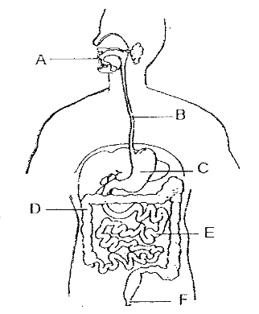

7.6B
- During the process of digestion foo is taken into the mouth, and several processes occur. The teeth and tongue act to grind and breakup food into smaller particles. At the same time, salivary amylase helps to begin the breakdown of complex carbohydrates into much smaller sugars. Which of the following is most true regarding these processes?
  - Both processes involve chemical changes.
  - Both processes involve physical changes.
  - Chewing is a physical process while the action of amylase is a chemical change.
  - Chewing is a chemical process while the action of amylase is a physical process.

7.6B

- Create a foldable in which the chemical and physical changes are listed in order as the food travels through the digestive system.
