8.5A

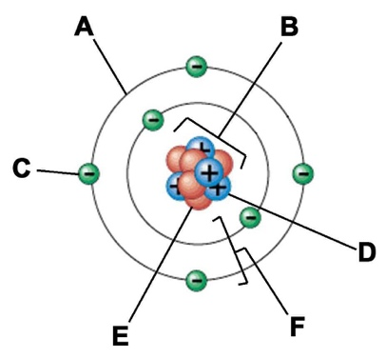
A) Label parts of the atom and fill in the table below.

Particle | Charge | Mass | Location
Proton
 |  |  | Nucleus
 | Negative (-)
8.5A

B) Fill in the P.E.N. for the following elements. Include the charge for each Particle.

Element | Protons | Electrons | Neutrons
Xenon
Cobalt
Tungsten
Lithium
Titanium
Arsenic

8.5A

C) Create an atom model of an assigned element using candy, glue and a paper plate.
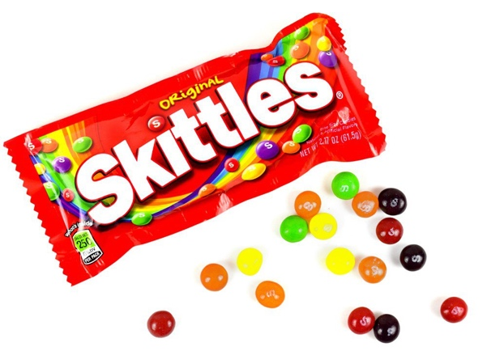
*Materials: Skittles, Glue and Paper Plates.
8.5A

D) Draw element boxes, P.E.N. and the Bohr Model for the following elements.
Neon | Oxygen
Aluminum | Helium

