8.5D

- List how many more H atoms are present in the formula than C atoms?

8.5D

- How many Oxygen atoms are in the following compounds?
Ca(NO₃)_{2 __________}
4CO_{2 _________}
HClO_{3 _________}
H₃PO_{4 _________}
2C₆H₁₂O_{6 __________}
K₂SO_{4 _________}
5H₂CO_{3 ___________}
NaC₂H₃O_{2 __________}
8.5D

- Create a model of two different compounds. Provide a color key noting what element is represented by each color. Illustrate your two models.
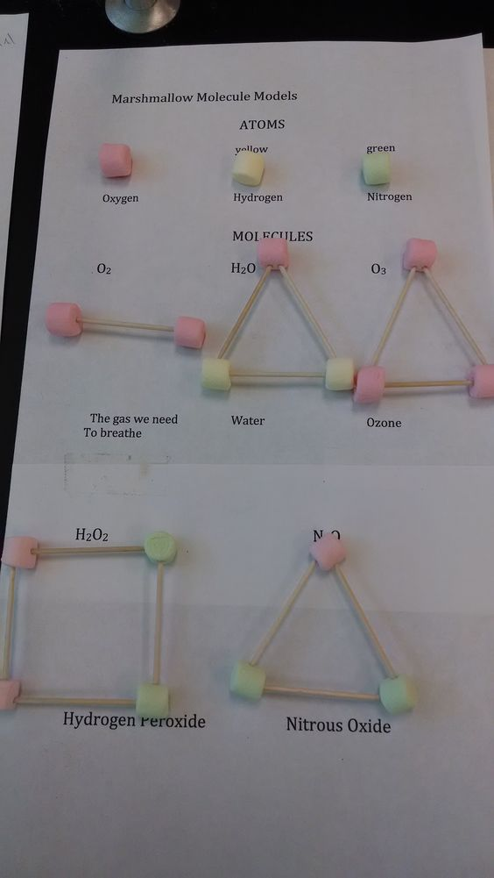

*Materials: Marshmallows and Toothpicks
8.5D

- The chemical equation describes the reaction of baking soda with vinegar.
NaHCO₃ + C₂H₄O₂ NaC₂H₃O₂ + CO₂ + H₂O
How many atoms react in this chemical reaction?
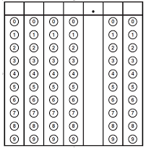
Record your answer and fill in the
Bubbles on the following grid.
Be sure to use the correct place value.

