8.5F

- A student drew the following model to describe a chemical reaction.

What is wrong with the model?
__________________________________________________________________________________________________________________________________________

8.5F

- Identify the following reactions as either balanced or balanced.
__________CO₂ + H₂O O₂ + C₆H₁₂O₆
__________C₃H₈ + 5O₂ 3CO₂ + 4H₂O
__________4CH₄ + O₂ 2CO₂ + H₂O
__________2P + 5O₂ 2P₂ + 2P₂O₅
__________CuO + H₂ Cu + H₂O
__________BaCO₂ BaO + CO₂

8.5F

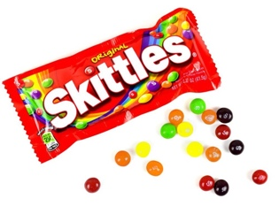
- Use different colored Skittles to balance the following equation. Provide a color key noting what element is represented by each color.

KClO₃ KCl + O₂

*Materials: Skittles
8.5F

- Explain why unbalanced equations must be balanced. Refer to the Law of Conservation of Matter in your answer.
________________________________________________________________________________________________________________________________________________________________________________________

