Inertia
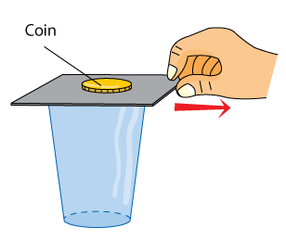
The tendency of an object to resist being moved or, if the object is moving, to resist a change in speed or direction.
Law of Inertia
Newton’s first law of motion, states that an object will not move or change its motion unless it is acted upon by an unbalanced force. In addition, a moving object will stay in motion with the same velocity, or speed in a particular direction, unless an unbalanced force changes its speed or direction.
Law of Force and Acceleration

Newton’s second law of motion, states that the acceleration of an object depends on the mass of the object and the net force applied.
Law of Action-Reaction
Newton’s third law of motion, states that whenever one object applies a force on a second object, the second object applies an equal and opposite force on the first object.
Sir Isacc Newton
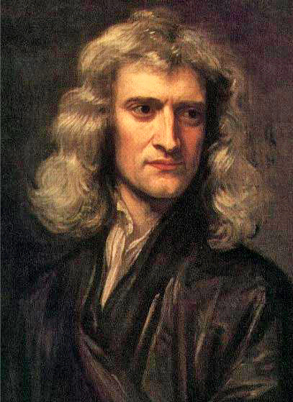
Was an English natural philosopher who laid the foundations for modern physical science. His work on gravity led him to develop his three laws of motion.

