Speed

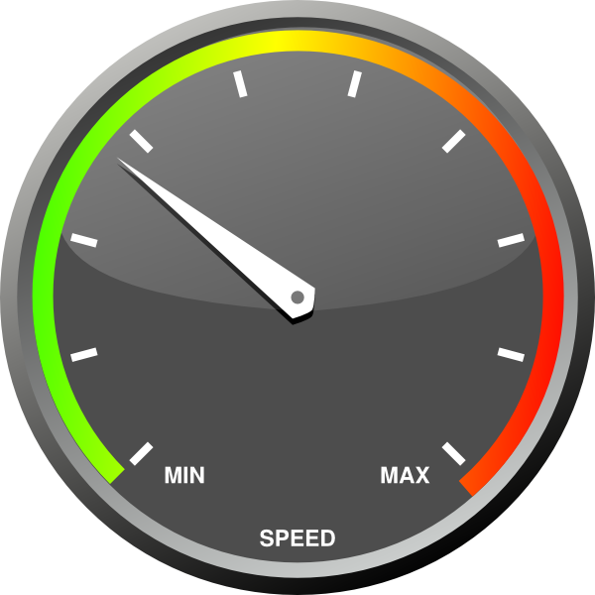

A measure of how fast something moves; rate of motion.
Velocity
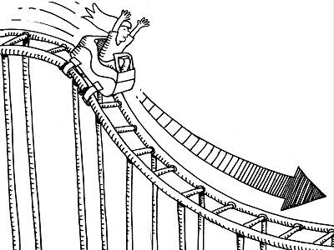

The speed of an object in a particular direction.

Acceleration

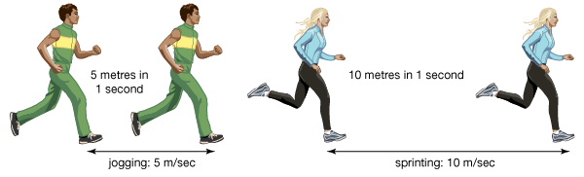

The rate at which velocity changes over time; an object accelerates if its speed, direction, or both change.
Displacement

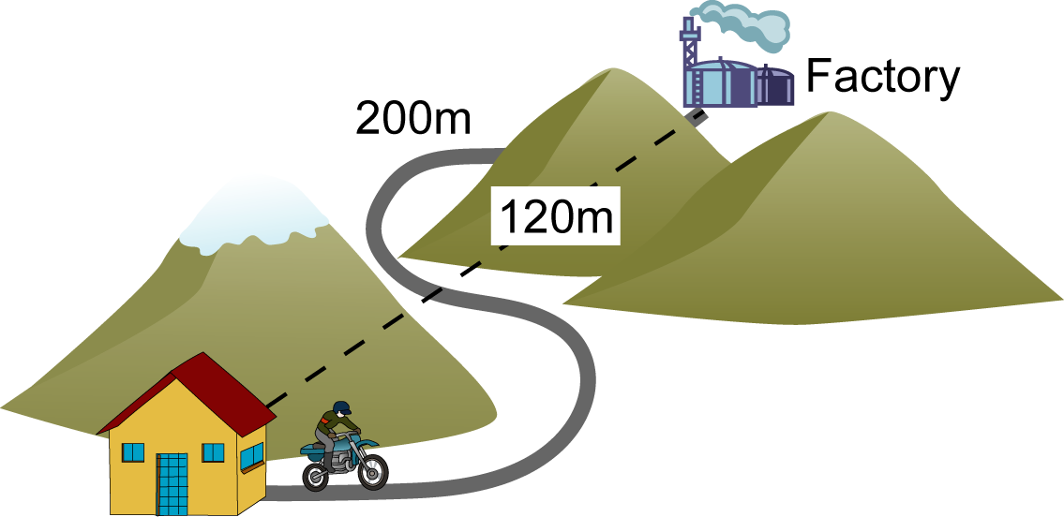

The change in position of an object.
Position

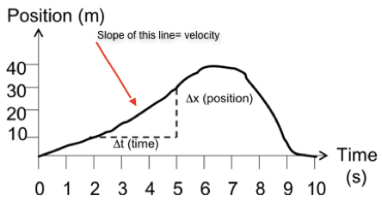

The location of an object.

Vector
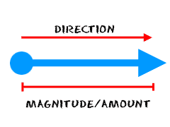

A quantity that has both size and direction.

Reference point

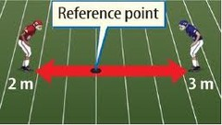

A location to which another location is compared.
Gravity
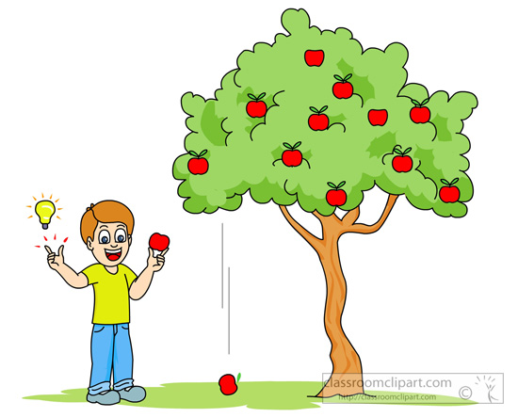
A force of attraction between objects that is due to their masses.
Instantaneous Speed

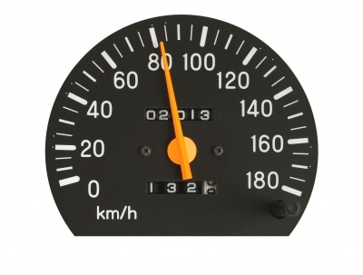
The rate of motion at a particular instant in time.

