Element

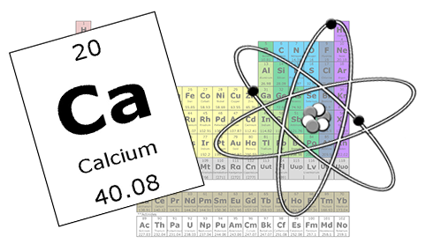

An element is a species of atoms having the same number of protons in their atomic nuclei.
Periodic Table
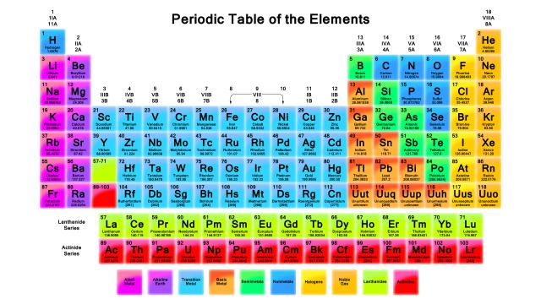
An arrangement of the elements in order of their atomic numbers such that elements with similar properties fall in the same column, or group.
Groups
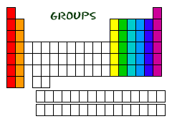
A vertical column of elements in the periodic table; elements in a group share chemical properties.
Periods
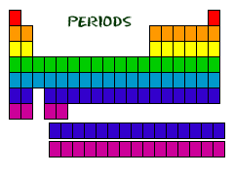
In chemistry, a horizontal row of elements in the periodic table.
Chemistry
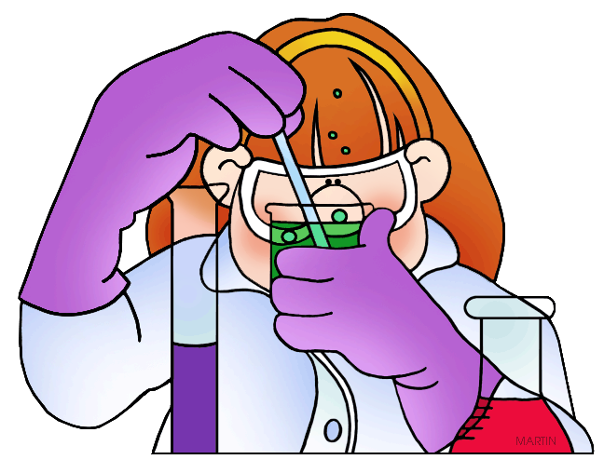
Chemistry is a branch of physical science that studies the composition, structure, properties and change of matter.
Metals
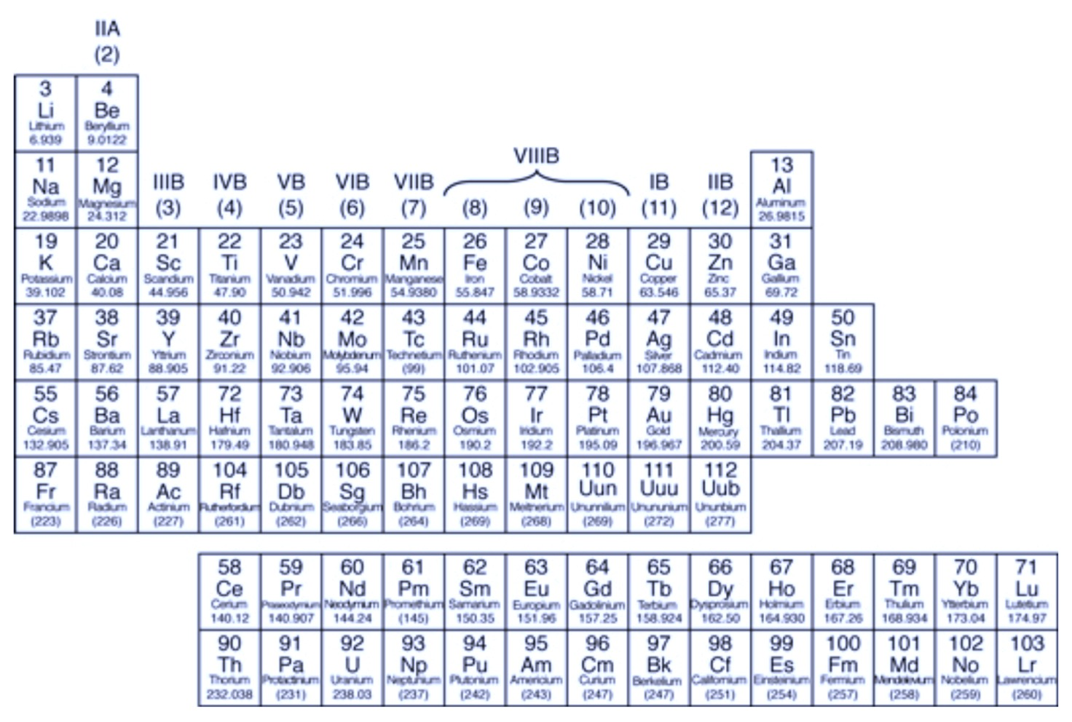
An element that is shiny and that conducts heat and electricity well.
Non-Metals
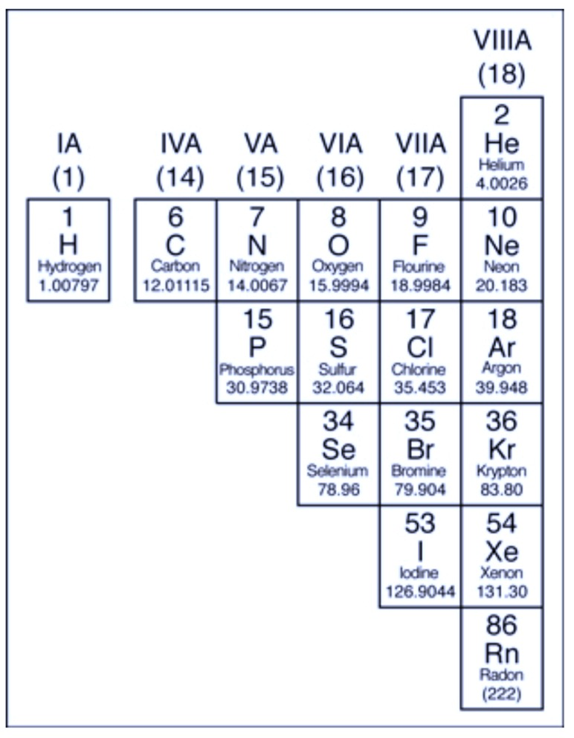
An Element that conducts heat and electricity poorly.
Metalloids
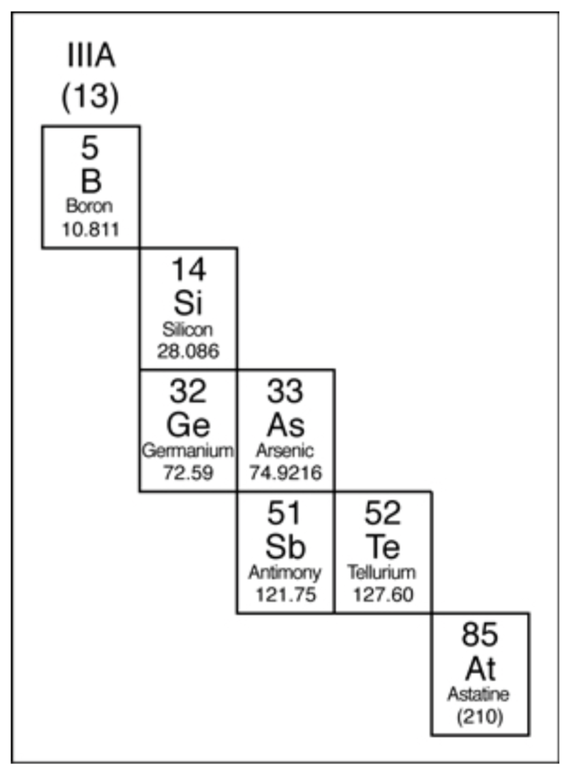
An element that has properties of both metals and non-metals.
Dmitri Mendeleev
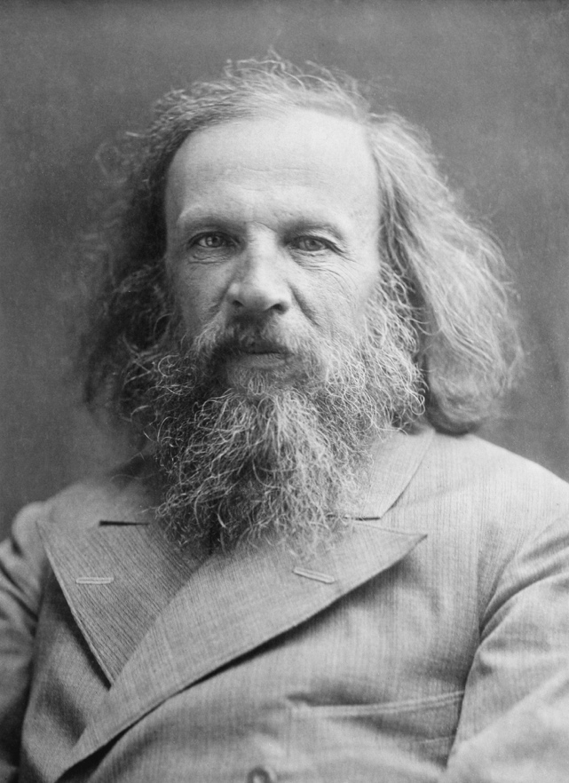

Russian chemist, that formulated the periodic law, created a farsighted version of the periodic table of elements, and used it to correct the properties of some already discovered elements and also to predict the properties of eight elements yet to be discovered.

